**Getting Started with ‘A Sign in Space’**

Please review the User’s Guide for installation instructions and usage.

For processing the A Sign in Space bitstream the best place to start is with the data17.bin

file. The suggested (but not required) folder structure for data and other files is something like:

This is what is initially installed when the application is installed under the installation directory.

Data

BMP files

last.bmp This is set in app Settings dialog, it will contain a

.BMP file representation of the the last output image

file operation. This was done to make viewing the last

image file (binary) operation easier without the need

to explicitly export the output result to a BMP file.

*.bmp bitmap image files saved

Convolution

kernel.txt Convolution kernel text file(s)

....

ReOrder

reorder.txt reorder kernel text file(s)

....

OriginalSource

Data17.bin The original message source, (you may wish to mark the file

readonly)

*.raw Raw image files, these are binary 2D image files with a 32 byte header

which can be loaded into Photoshop or Gimp easily. Photoshop

expected a raw file to have the extension .raw.

You can the properties of an image file under the

Image tools -> Image file properties menu selection.

*.txt text files, such as csv or report file

**Extracting the various parts of the Bitstream file Data17.bin**

**Extract the entire bitstream to a text file**

Bit tools -> Extract full bitstream to text

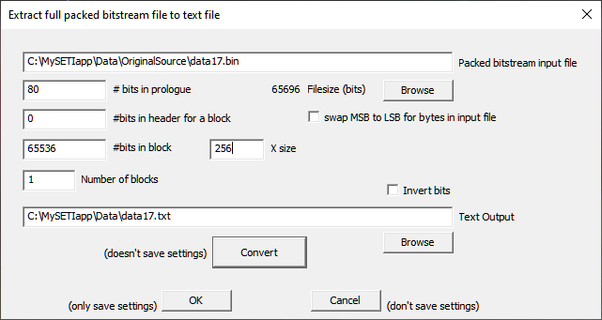

**Extract the header as an image**

Bit Tools -> BitStream to Binary Image

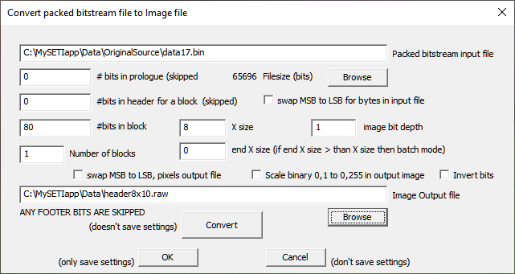

**Extract the message body as an image**

This is what has been referred to online as the ‘starmap’.

Bit Tools -> BitStream to Binary Image

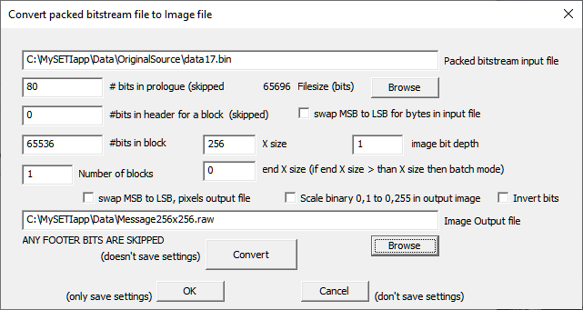

**Extract the footer as an image**

Bit Tools -> BitStream to Binary Image

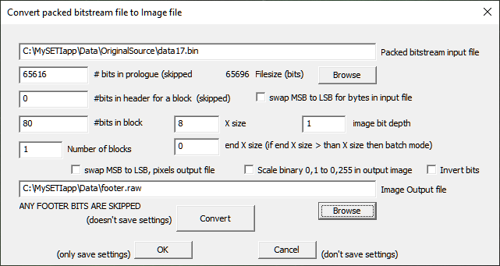

Thes are just the start. A number of files are included in the installation that have already been converted or extracted from the bitstream.

Happy deciphering.

**The Arecibo message**

The Arecibo message was a message transmitted by the Arecibo radio telescope on November 16,1974. It was focused at Messier 13 a globular cluster approx. 25,000 lightyears away. The text file for the message is in the directory, C:\MySETIapp\Data\Arecibo\Arecibo_message.txt.

Converting the Arecibo_message.txt into a binary bitstream file.

Bit tools -> Convert text file to packed bitstream

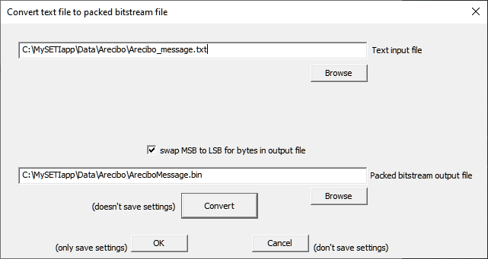

You can try turning the MSB to LSB swap on and off to see its effect on the decoded message.

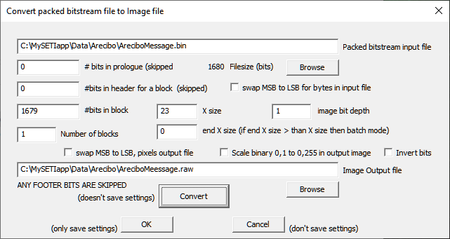

The Arecibo message

